YMCA Bellshill & Mossend: Consent

Young Person’s Details:
Name: | D.o.B:
Address:

Emergency contact:
Name:
Relationship: | Phone number:

Additional Information:
Please provide information on any medical conditions which may impact your involvement in the programme (please include any medication you take which staff should be aware of, and the contact details for your doctor if appropriate):

Do you have any additional support needs, or is there anything that staff should be aware of to help support you through the programme (e.g. do you need help filling in forms)?:

Consent:
Please initial the following to give your consent
Aspect of programme |  |  | Initial to give consent
 | Photos/ Video | We sometimes take photos an videos of sessions to evidence to funders what we’ve been doing, and help you keep a record of your progress
 | Social media | We sometimes post on social media to let other young people know what we get up to
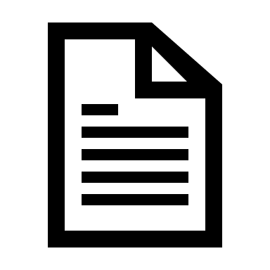 | Anonymous case studies | Sometimes we will write about what a young person did on our programme, but we wouldn’t use your name

I consent to taking part in the programme with YMCA Bellshill & Mossend.

Signed:

Print name:

Date:

Guardian Consent:
If the young person is under 16 years of age, consent to take part in YMCA Bellshill programmes is also required from a parent/carer.

I give consent for to take part in programmes with YMCA Bellshill & Mossend.

Signed:

Print name:

Relationship:

Date:

If you require further information about any of our programmes please go to our website (ymcabellshill.org) or get in touch.

